UNITED STATES
SECURITIES AND EXCHANGE COMMISSION
Washington, D.C. 20549

SCHEDULE 14A
(RULE 14a-101)
INFORMATION REQUIRED IN PROXY STATEMENT
SCHEDULE 14A INFORMATION
PROXY STATEMENT PURSUANT TO SECTION 14(a) OF THE
SECURITIES EXCHANGE ACT OF 1934

Filed by the Registrant | ☒
Filed by a Party other than the Registrant | ☐

Check the appropriate box:

☐ | Preliminary Proxy Statement
☐ | Confidential, for Use of the Commission Only (as permitted by Rule 14a-6(e)(2))
☐ | Definitive Proxy Statement
☒ | Definitive Additional Materials
☐ | Soliciting Material Pursuant to Rule 14a-12

Oxford Square Capital Corp.
(Name of Registrant as Specified in Its Charter)

(Name of Person(s) Filing Proxy Statement if other than the Registrant)

Payment of Filing Fee (Check the appropriate box):

☒ | No fee required.
☐ | Fee paid previously with preliminary materials.
☐ | Fee computed on table in exhibit required by Item 25(b) per Exchange Act Rules 14a-6(i)(1) and 0-11.

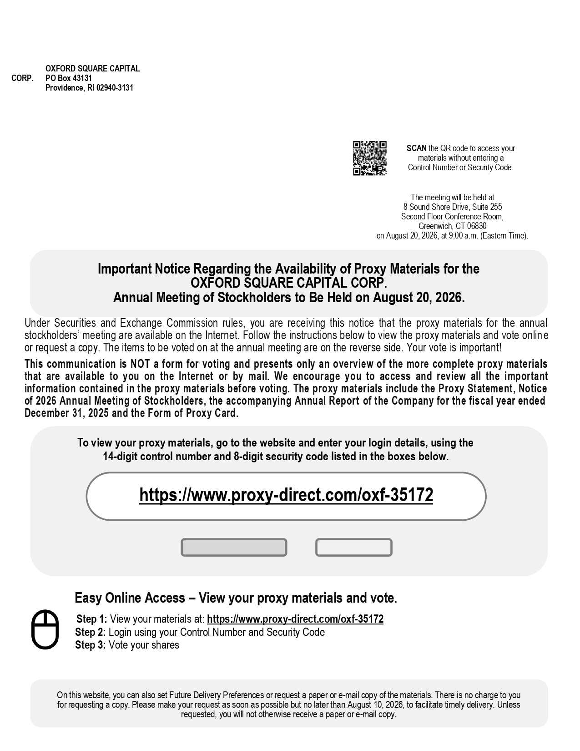
OXFORD SQUARE CAPITAL CORP. PO Box 43131 Providence, RI 02940 - 3131 https://www.proxy - direct.com/oxf - 35172 Easy Online Access – View your proxy materials and vote. Step 1: View your materials at: https://www.proxy - direct.com/oxf - 35172 Step 2: Login using your Control Number and Security Code Step 3: Vote your shares On this website, you can also set Future Delivery Preferences or request a paper or e - mail copy of the materials. There is no charge to you for requesting a copy. Please make your request as soon as possible but no later than August 10, 2026, to facilitate timely delivery. Unless requested, you will not otherwise receive a paper or e - mail copy . SCAN the QR code to access your materials without entering a Control Number or Security Code. The meeting will be held at 8 Sound Shore Drive, Suite 255 Second Floor Conference Room, Greenwich, CT 06830 on August 20, 2026, at 9:00 a.m. (Eastern Time). Important Notice Regarding the Availability of Proxy Materials for the OXFORD SQUARE CAPITAL CORP. Annual Meeting of Stockholders to Be Held on August 20, 2026. Under Securities and Exchange Commission rules, you are receiving this notice that the proxy materials for the annual stockholders’ meeting are available on the Internet . Follow the instructions below to view the proxy materials and vote onlin e or request a copy . The items to be voted on at the annual meeting are on the reverse side . Your vote is important! This communication is NOT a form for voting and presents only an overview of the more complete proxy materials that are available to you on the Internet or by mail . We encourage you to access and review all the important information contained in the proxy materials before voting . The proxy materials include the Proxy Statement, Notice of 2026 Annual Meeting of Stockholders, the accompanying Annual Report of the Company for the fiscal year ended December 31 , 2025 and the Form of Proxy Card . To view your proxy materials, go to the website and enter your login details, using the 14 - digit control number and 8 - digit security code listed in the boxes below .

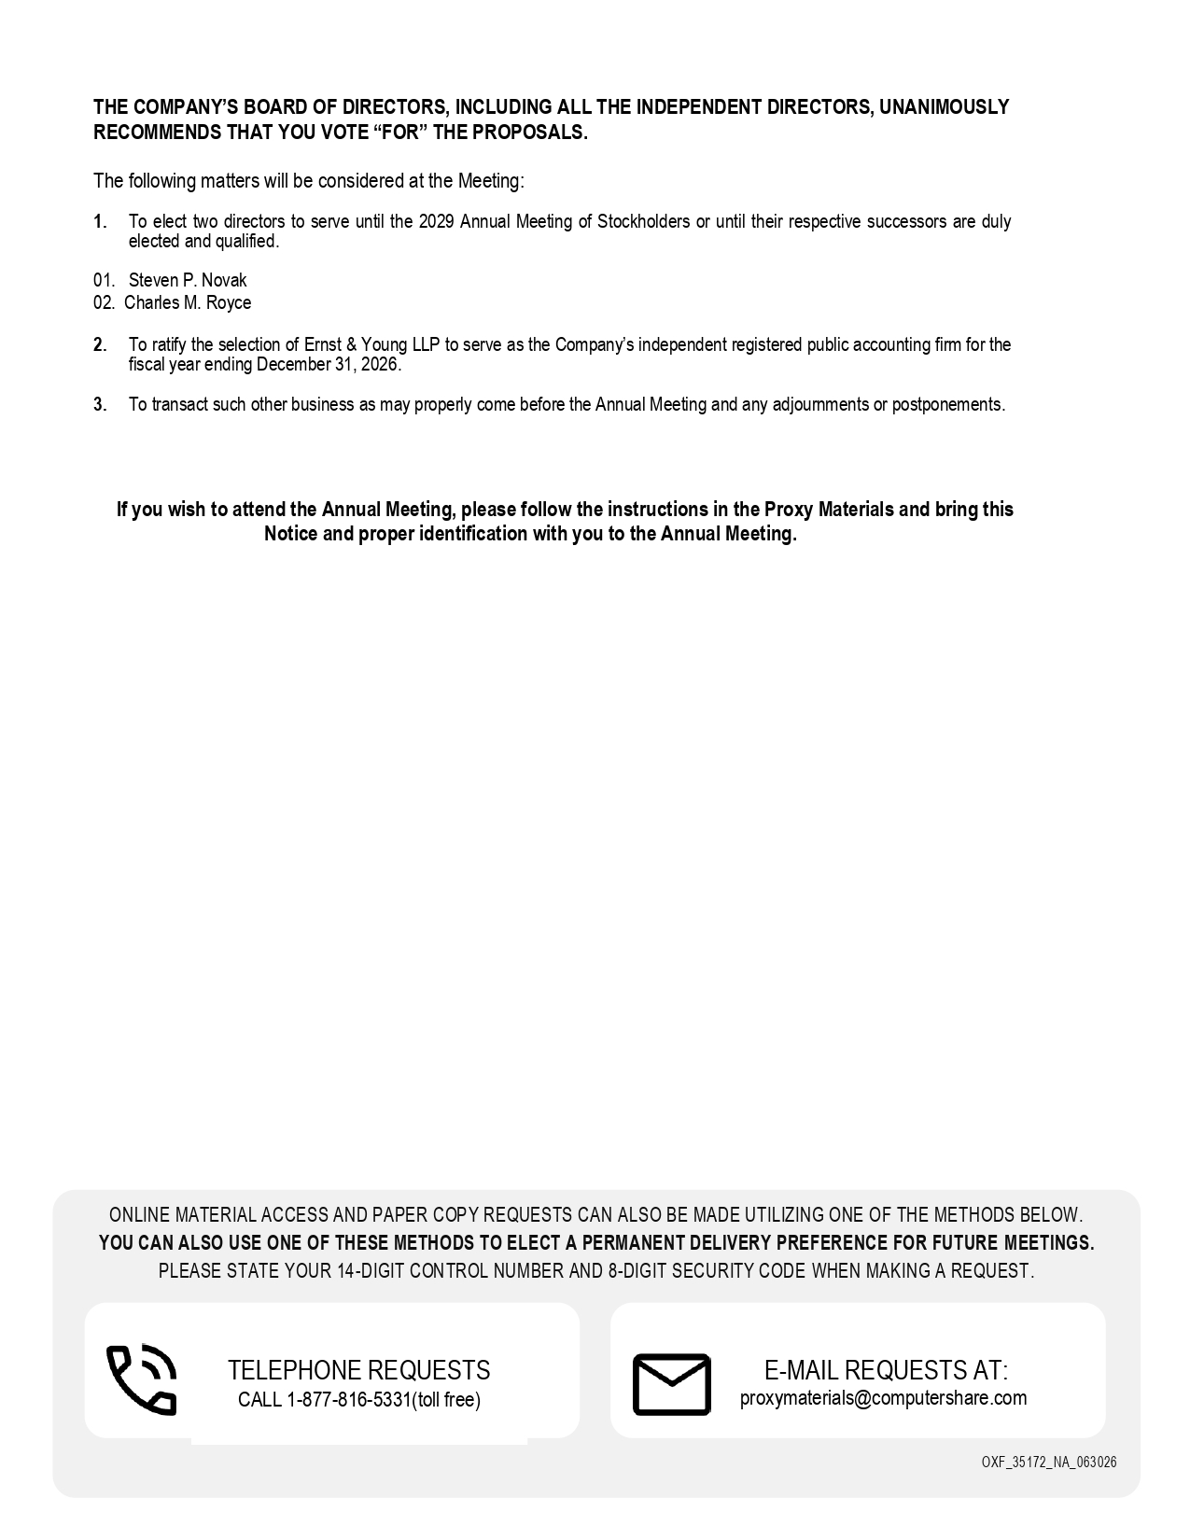
THE COMPANY’S BOARD OF DIRECTORS, INCLUDING ALL THE INDEPENDENT DIRECTORS, UNANIMOUSLY RECOMMENDS THAT YOU VOTE “FOR” THE PROPOSALS. The following matters will be considered at the Meeting: 1. To elect two directors to serve until the 2029 Annual Meeting of Stockholders or until their respective successors are duly elected and qualified. 1. Steven P. Novak 2. Charles M. Royce 2. To ratify the selection of Ernst & Young LLP to serve as the Company’s independent registered public accounting firm for the fiscal year ending December 31, 2026. 3. To transact such other business as may properly come before the Annual Meeting and any adjournments or postponements. If you wish to attend the Annual Meeting, please follow the instructions in the Proxy Materials and bring this Notice and proper identification with you to the Annual Meeting. ONLINE MATERIAL ACCESS AND PAPER COPY REQUESTS CAN ALSO BE MADE UTILIZING ONE OF THE METHODS BELOW. YOU CAN ALSO USE ONE OF THESE METHODS TO ELECT A PERMANENT DELIVERY PREFERENCE FOR FUTURE MEETINGS. PLEASE STATE YOUR 14 - DIGIT CONTROL NUMBER AND 8 - DIGIT SECURITY CODE WHEN MAKING A REQUEST. OXF_35172_NA_063026 TELEPHONE REQUESTS CALL 1 - 877 - 816 - 5331(toll free) E - MAIL REQUESTS AT: proxymaterials@computershare.com

